**Furniture Shop**  
**Database Management System**

**Welcome to Crafted Comforts Furniture Shop**

At Crafted Comforts Furniture Shop, we believe that your home is a reflection of your personality, and we're here to help you create a space that is both beautiful and functional. Our passion for quality furniture and commitment to exceptional customer service sets us apart in the world of home decor.

**Our Vision**

Our vision is to provide a diverse selection of stylish and durable furniture that caters to every taste and budget. Whether you're looking for modern minimalism, rustic charm, or classic elegance, we have something to suit your needs.

**What We Offer**

* **Quality Products**: We source our furniture from reputable manufacturers, ensuring that every piece meets our high standards of quality and craftsmanship.
* **Customization Options**: At Crafted Comforts Furniture Shop, we understand that every home is unique. That's why we offer customization options on many of our products, allowing you to choose the perfect color, material, and size.
* **Expert Guidance**: Our knowledgeable staff is here to assist you at every step, providing personalized recommendations and expert advice to help you make informed choices.
* **Affordable Prices**: We strive to offer competitive pricing without compromising on quality. Our furniture is designed to provide great value for your investment.
* **Customer Satisfaction**: Your satisfaction is our top priority. We stand by our products and offer a hassle-free return policy to ensure you’re completely happy with your purchase.

**Visit Us**

Explore our extensive showroom, where you can browse our wide range of furniture, from cozy sofas and elegant dining sets to functional office furniture and stylish decor. Our friendly team is ready to help you find the perfect pieces to enhance your home.

**Join Our Community**

Stay connected with us through our social media channels and subscribe to our newsletter for the latest updates on new arrivals, special offers, and design tips.

At Crafted Comforts Furniture Shop, we’re not just selling furniture; we’re helping you create the home of your dreams. Come visit us today!

**Raw Diagram**

**+------------------+**

**| Customers |**

**+------------------+**

**|**

**|**

**+------------------+**

**| Orders |**

**+------------------+**

**|**

**|**

**+------------------+**

**| OrderItems |**

**+------------------+**

**|**

**|**

**+------------------+ +------------------+**

**| Furniture |<---| CustomizationOptions |**

**+------------------+ +------------------+**

**|**

**|**

**+------------------+**

**| Inventory |**

**+------------------+**

**|**

**|**

**+------------------+**

**| Suppliers |**

**+------------------+**

**|**

**|**

**+------------------+**

**| Payments |**

**+------------------+**

**|**

**|**

**+------------------+**

**| Employees |**

**+------------------+**

**Create Tables –**

Create database **Furniture_shop**;

use **Furniture_shop**;

CREATE TABLE **Customers** (

CustomerID INT PRIMARY KEY AUTO_INCREMENT,

FirstName VARCHAR(50) NOT NULL,

LastName VARCHAR(50) NOT NULL,

Email VARCHAR(100) NOT NULL UNIQUE,

PhoneNumber VARCHAR(15),

Address VARCHAR(255)

);

CREATE TABLE **Furniture** (

FurnitureID INT PRIMARY KEY AUTO_INCREMENT,

FurnitureName VARCHAR(100) NOT NULL,

Category VARCHAR(50) NOT NULL,

MaterialType ENUM('Fabric', 'Wood', 'Metal', 'Leather', 'Glass', 'Plastic', 'Engineered Wood') NOT NULL,

Color VARCHAR(30),

Size VARCHAR(30),

Price DECIMAL(10, 2) NOT NULL,

InStockQuantity INT NOT NULL,

IsCustomizable BOOLEAN DEFAULT FALSE

);

CREATE TABLE **CustomizationOptions** (

CustomizationID INT PRIMARY KEY AUTO_INCREMENT,

FurnitureID INT,

OptionType ENUM('Color', 'Material', 'Size', 'Fabric Type', 'Shelf Count', 'Glass Type', 'Wood Finish', 'Leather Type', 'Seat Type') NOT NULL,

OptionDescription VARCHAR(100) NOT NULL,

AdditionalCost DECIMAL(10, 2) NOT NULL,

FOREIGN KEY (FurnitureID) REFERENCES Furniture(FurnitureID)

);

CREATE TABLE **Orders** (

OrderID INT PRIMARY KEY AUTO_INCREMENT,

CustomerID INT,

SalesPersonID int,

OrderDate DATE NOT NULL ,

TotalAmount DECIMAL(10, 2) NOT NULL,

OrderStatus ENUM('Pending', 'In Progress', 'Completed', 'Shipped', 'Cancelled', 'Returned') NOT NULL,

ReturnReason VARCHAR(255), -- Add the ReturnReason colum

DeliveryDate DATE,

IsCustomized BOOLEAN DEFAULT FALSE,

FOREIGN KEY (CustomerID) REFERENCES Customers(CustomerID)

);

CREATE TABLE **OrderItems** (

OrderItemID INT PRIMARY KEY AUTO_INCREMENT ,

OrderID INT,

FurnitureID INT,

Quantity INT NOT NULL,

UnitPrice DECIMAL(10, 2) NOT NULL,

TotalPrice DECIMAL(10, 2) NOT NULL,

CustomizationID INT,

FOREIGN KEY (OrderID) REFERENCES Orders(OrderID) ,

FOREIGN KEY (FurnitureID) REFERENCES Furniture(FurnitureID) ,

FOREIGN KEY (CustomizationID) REFERENCES CustomizationOptions(CustomizationID)

);

CREATE TABLE **Suppliers** (

SupplierID INT PRIMARY KEY AUTO_INCREMENT,

SupplierName VARCHAR(100) NOT NULL,

ContactName VARCHAR(100),

Phone VARCHAR(15),

Email VARCHAR(100) UNIQUE,

Address VARCHAR(255),

ProductType ENUM('Wood', 'Metal', 'Fabric', 'Foam & Cushions','Glass') NOT NULL

);

CREATE TABLE **Inventory** (

InventoryID INT PRIMARY KEY AUTO_INCREMENT,

FurnitureID INT,

SupplierID INT,

Quantity INT NOT NULL,

RestockDate DATE,

FOREIGN KEY (FurnitureID) REFERENCES Furniture(FurnitureID) ,

FOREIGN KEY (SupplierID) REFERENCES Suppliers(SupplierID)

);

CREATE TABLE **Payments** (

PaymentID INT PRIMARY KEY AUTO_INCREMENT ,

OrderID INT,

PaymentDate DATE NOT NULL ,

AmountPaid DECIMAL(10, 2) NOT NULL,

PaymentMethod ENUM('Debit Card', 'Cash', 'UPI') NOT NULL,

PaymentStatus ENUM('Paid', 'Pending', 'Failed', 'Half_Paid' ) NOT NULL,

FOREIGN KEY (OrderID) REFERENCES Orders(OrderID)

);

CREATE TABLE **Employees** (

EmployeeID INT PRIMARY KEY AUTO_INCREMENT,

FirstName VARCHAR(50) NOT NULL,

LastName VARCHAR(50) NOT NULL,

Position ENUM('Salesperson', 'Designer', 'Delivery Staff', 'Cashier') NOT NULL,

Phone VARCHAR(15),

Email VARCHAR(100) UNIQUE,

salary DECIMAL(10, 2) NOT NULL

);

**INSERT Values**

-- **Customers**

INSERT INTO **Customers** (CustomerID, FirstName, LastName, Email, PhoneNumber, Address) VALUES

(1, 'Ramesh', 'Sharma', 'ramesh.sharma@gmail.com', '9876543210', 'Mumbai, Maharashtra'),

(2, 'Anjali', 'Verma', 'anjali.verma@gmail.com', '9123456789', 'New Delhi, Delhi'),

(3, 'Suresh', 'Patel', 'suresh.patel@gmail.com', '9988776655', 'Ahmedabad, Gujarat'),

(4, 'Priya', 'Singh', 'priya.singh@gmail.com', '9876501234', 'Jaipur, Rajasthan'),

(5, 'Vikas', 'Gupta', 'vikas.gupta@gmail.com', '9123498765', 'Pune, Maharashtra'),

(6, 'Neha', 'Kulkarni', 'neha.kulkarni@gmail.com', '9988771234', 'Nagpur, Maharashtra'),

(7, 'Ravi', 'Desai', 'ravi.desai@gmail.com', '9123487654', 'Surat, Gujarat'),

(8, 'Meera', 'Menon', 'meera.menon@gmail.com', '9876523456', 'Chennai, Tamil Nadu'),

(9, 'Amit', 'Agarwal', 'amit.agarwal@gmail.com', '9123409876', 'Kolkata, West Bengal'),

(10, 'Pooja', 'Rao', 'pooja.rao@gmail.com', '9988776543', 'Bangalore, Karnataka'),

(11, 'Rajesh', 'Mishra', 'rajesh.mishra@gmail.com', '9123432109', 'Lucknow, Uttar Pradesh'),

(12, 'Sneha', 'Yadav', 'sneha.yadav@gmail.com', '9876512345', 'Indore, Madhya Pradesh'),

(13, 'Ankit', 'Kapoor', 'ankit.kapoor@gmail.com', '9123498761', 'Chandigarh, Punjab'),

(14, 'Deepa', 'Reddy', 'deepa.reddy@gmail.com', '9876540987', 'Hyderabad, Telangana'),

(15, 'Nitin', 'Jain', 'nitin.jain@gmail.com', '9123456780', 'Noida, Uttar Pradesh'),

(16, 'Sakshi', 'Kumar', 'sakshi.kumar@gmail.com', '9988765432', 'Bhopal, Madhya Pradesh'),

(17, 'Kiran', 'Bose', 'kiran.bose@gmail.com', '9123401234', 'Patna, Bihar'),

(18, 'Ajay', 'Shetty', 'ajay.shetty@gmail.com', '9876532109', 'Thane, Maharashtra'),

(19, 'Geeta', 'Pillai', 'geeta.pillai@gmail.com', '9123478901', 'Kochi, Kerala'),

(20, 'Arjun', 'Nair', 'arjun.nair@gmail.com', '9876543211', 'Trivandrum, Kerala');

-- **Furniture**

INSERT INTO **Furniture** (FurnitureID, FurnitureName, Category, MaterialType, Color, Size, Price, InStockQuantity, IsCustomizable) VALUES

(1, 'Sofa Set', 'Sofa', 'Fabric', 'Blue', '3-seater', 25000, 5, TRUE),

(2, 'Dining Table', 'Table', 'Wood', 'Brown', '4-seater', 15000, 10, TRUE),

(3, 'Office Chair', 'Chair', 'Metal', 'Black', 'Standard', 5000, 15, FALSE),

(4, 'Double Bed', 'Bed', 'Wood', 'Mahogany', 'Queen size', 30000, 3, TRUE),

(5, 'Coffee Table', 'Table', 'Glass', 'Clear', 'Medium', 8000, 7, FALSE),

(6, 'Bookshelf', 'Shelf', 'Wood', 'Walnut', 'Tall', 12000, 8, TRUE),

(7, 'Recliner Sofa', 'Sofa', 'Leather', 'Brown', '2-seater', 35000, 4, TRUE),

(8, 'Bunk Bed', 'Bed', 'Metal', 'White', 'Twin size', 20000, 6, FALSE),

(9, 'Wardrobe', 'Storage', 'Wood', 'Oak', 'Large', 18000, 2, TRUE),

(10, 'Dining Chair', 'Chair', 'Wood', 'Dark Brown', 'Standard', 2500, 20, FALSE),

(11, 'TV Stand', 'Stand', 'Wood', 'Black', 'Medium', 7000, 9, FALSE),

(12, 'Armchair', 'Chair', 'Fabric', 'Gray', 'Single', 6000, 12, TRUE),

(13, 'Kitchen Cabinet', 'Cabinet', 'Wood', 'White', 'Large', 22000, 5, TRUE),

(14, 'Patio Table', 'Outdoor Table', 'Plastic', 'Green', '4-seater', 5000, 11, FALSE),

(15, 'Nightstand', 'Table', 'Wood', 'Teak', 'Small', 3000, 10, FALSE),

(16, 'Study Desk', 'Desk', 'Engineered Wood', 'White', 'Standard', 10000, 7, TRUE),

(17, 'Dresser', 'Storage', 'Wood', 'Cherry', 'Large', 15000, 6, TRUE),

(18, 'Bean Bag', 'Chair', 'Fabric', 'Red', 'Single', 2000, 25, FALSE),

(19, 'Display Cabinet', 'Cabinet', 'Glass', 'Transparent', 'Medium', 12000, 3, TRUE),

(20, 'Ottoman', 'Footrest', 'Leather', 'Cream', 'Small', 3500, 14, FALSE);

-- **CustomizationOptions**

INSERT INTO **CustomizationOptions** (CustomizationID, FurnitureID, OptionType, OptionDescription, AdditionalCost) VALUES

(1, 1, 'Color', 'Red', 1000),

(2, 2, 'Material', 'Teak Wood', 5000),

(3, 4, 'Size', 'King Size', 8000),

(4, 1, 'Fabric Type', 'Leather', 7000),

(5, 7, 'Color', 'Dark Gray', 1500),

(6, 9, 'Material', 'Pine Wood', 3000),

(7, 6, 'Shelf Count', '5 Shelves', 2000),

(8, 5, 'Glass Type', 'Tinted', 1200),

(9, 12, 'Fabric Type', 'Velvet', 2500),

(10, 13, 'Color', 'Matte Black', 1800),

(11, 17, 'Size', 'Extra Large', 5000),

(12, 10, 'Wood Finish', 'Glossy Finish', 700),

(13, 8, 'Color', 'Blue', 1000),

(14, 15, 'Material', 'Bamboo Wood', 1200),

(15, 18, 'Color', 'Yellow', 500),

(16, 19, 'Glass Type', 'Frosted Glass', 2000),

(17, 14, 'Color', 'Brown', 800),

(18, 20, 'Leather Type', 'Italian Leather', 3000),

(19, 7, 'Seat Type', 'Memory Foam', 4000),

(20, 16, 'Color', 'Dark Walnut', 1500);

-- **Orders**

INSERT INTO **Orders** (OrderID, CustomerID, OrderDate, TotalAmount, OrderStatus, ReturnReason, DeliveryDate, IsCustomized) VALUES

(1, 1, '2024-10-01', 28000, 'Completed', NULL, '2024-10-10', TRUE),

(2, 2, '2024-10-03', 5000, 'Pending', NULL, '2024-10-15', FALSE),

(3, 3, '2024-10-05', 38000, 'In Progress', NULL, '2024-10-20', TRUE),

(4, 4, '2024-10-07', 15000, 'Completed', NULL, '2024-10-15', FALSE),

(5, 5, '2024-10-08', 22000, 'Pending', NULL, '2024-10-18', TRUE),

(6, 6, '2024-10-09', 12000, 'Completed', NULL, '2024-10-16', FALSE),

(7, 7, '2024-10-10', 7000, 'In Progress', NULL, '2024-10-22', FALSE),

(8, 8, '2024-10-11', 50000, 'Shipped', NULL, '2024-10-25', TRUE),

(9, 9, '2024-10-12', 2500, 'Cancelled', NULL, '2024-10-20',FALSE),

(10, 10, '2024-10-21', 27500, 'Pending', NULL, '2024-10-31', TRUE),

(11, 11, '2024-10-22', 4800, 'Completed', NULL, '2024-10-29', FALSE),

(12, 12, '2024-10-23', 5200, 'Cancelled', NULL, '2024-10-30', FALSE),

(13, 12, '2024-10-24', 15000, 'Returned', 'Customer Changed Mind', NULL, TRUE),

(14, 14, '2024-10-25', 20000, 'Returned', 'Damaged During Delivery', NULL, FALSE),

(15, 15, '2024-10-26', 12000, 'Returned', 'Received Wrong Item', NULL, TRUE),

(16, 16, '2024-10-27', 45000, 'Returned', 'Item Not as Described', NULL, FALSE),

(17, 17, '2024-10-28', 30000, 'Returned', 'Defective Product', NULL, TRUE),

(18, 18, '2024-10-29', 25000, 'Returned', 'Color Did Not Match Expectation', NULL, FALSE),

(19, 19, '2024-10-30', 18000, 'Returned', 'Quality Not as Expected', NULL, TRUE),

(20, 20, '2024-10-31', 16000, 'Returned', 'Incompatible with Existing Furniture', NULL, FALSE);

-- **OrderItems**

INSERT INTO **OrderItems** (OrderItemID, OrderID, FurnitureID, Quantity, UnitPrice, TotalPrice, CustomizationID) VALUES

(1, 1, 1, 1, 25000, 28000, 1),

(2, 2, 3, 1, 5000, 5000, NULL),

(3, 3, 4, 1, 30000, 38000, 3),

(4, 4, 2, 1, 15000, 15000, NULL),

(5, 5, 5, 2, 8000, 18000, 8),

(6, 6, 7, 1, 7000, 7000, NULL),

(7, 7, 8, 1, 50000, 50000, 10),

(8, 8, 9, 3, 2500, 7500, NULL),

(9, 9, 6, 1, 12000, 12000, NULL),

(10, 10, 11, 1, 18000, 20000, 11),

(11, 11, 13, 1, 8000, 8000, NULL),

(12, 12, 14, 1, 45000, 53000, 14),

(13, 13, 15, 1, 12000, 12000, NULL),

(14, 14, 16, 2, 1100, 2200, NULL),

(15, 15, 17, 1, 6000, 7000, 17),

(16, 16, 18, 1, 33000, 38000, 18),

(17, 17, 20, 1, 12500, 15500, 20),

(18, 18, 19, 2, 2400, 4800, NULL),

(19, 19, 12, 1, 4500, 5200, 12),

(20, 20, 10, 1, 5000, 5000, NULL);

-- **Suppliers**

INSERT INTO **Suppliers** (SupplierID, SupplierName, ContactName, Phone, Email, Address, ProductType) VALUES

(1, 'Royal Woods', 'Amit Singh', '9876543210', 'amit@royalwoods.com', 'Jaipur, Rajasthan', 'Wood'),

(2, 'Fabric House', 'Priya Menon', '9123456789', 'priya@fabrichouse.com', 'Surat, Gujarat', 'Fabric'),

(3, 'Metal Makers', 'Vishal Iyer', '9988776655', 'vishal@metalmakers.com', 'Pune, Maharashtra', 'Metal'),

(4, 'Glassworks India', 'Ravi Deshmukh', '9867541230', 'ravi@glassworksindia.com', 'Mumbai, Maharashtra', 'Glass'),

(5, 'Cushion Comfort', 'Shweta Nair', '9998887766', 'shweta@cushioncomfort.com', 'Bangalore, Karnataka', 'Foam & Cushions');

-- **Inventory**

INSERT INTO **Inventory** (InventoryID, FurnitureID, SupplierID, Quantity, RestockDate) VALUES

(1, 1, 2, 10, '2024-09-01'),

(2, 2, 1, 8, '2024-09-10'),

(3, 3, 3, 20, '2024-09-15'),

(4, 4, 1, 5, '2024-09-18'),

(5, 5, 2, 15, '2024-09-20'), -- Sofa Set

(6, 6, 1, 12, '2024-09-25'), -- Dining Chair

(7, 7, 3, 25, '2024-09-30'), -- Office Desk

(8, 8, 4, 7, '2024-10-01'), -- Coffee Table

(9, 9, 2, 30, '2024-10-05'), -- Bookshelf

(10, 10, 1, 10, '2024-10-10'), -- Recliner Chair

(11, 11, 3, 20, '2024-10-15'), -- Side Table

(12, 12, 2, 18, '2024-10-20'), -- King Size Bed

(13, 13, 4, 5, '2024-10-25'), -- Night Stand

(14, 14, 3, 22, '2024-10-30'); -- TV Unit

-- **Payments**

INSERT INTO **Payments** (PaymentID, OrderID, PaymentDate, AmountPaid, PaymentMethod, PaymentStatus) VALUES

(1, 1, '2024-10-02', 28000, 'debit Card', 'Paid'),

(2, 2, '2024-10-04', 5000, 'UPI', 'Pending'),

(3, 3, '2024-10-06', 15000, 'UPI', 'Paid'),

(4, 4, '2024-10-02', 25000, 'Debit Card', 'Paid'), -- Payment for Sofa Set (Order ID 1)

(5, 5, '2024-10-05', 15000, 'Cash', 'Paid'), -- Payment for Dining Table (Order ID 2)

(6, 6, '2024-10-03', 30000, 'Debit Card', 'Paid'), -- Second payment for customized Double Bed (Order ID 1)

(7, 7, '2024-10-06', 8000, 'UPI', 'Paid'), -- Payment for Office Chair (Order ID 2)

(8, 8, '2024-10-07', 20000, 'Debit Card', 'Paid'), -- Payment for another Sofa Set (Order ID 3)

(9, 9, '2024-10-08', 7000, 'Cash', 'Paid'), -- Partial payment for customized Dining Table (Order ID 1)

(10, 10, '2024-10-09', 5000, 'UPI', 'Paid'), -- Payment for Coffee Table (Order ID 4)

(11, 11, '2024-10-10', 18000, 'Debit Card', 'Paid'), -- Payment for King Size Bed (Order ID 3)

(12, 12, '2024-10-11', 12000, 'UPI', 'Paid'), -- Payment for Recliner Chair (Order ID 2),

(13, 13, '2024-10-12', 35000, 'Debit Card', 'Paid'), -- Payment for Office Desk (Order ID 6)

(15, 15, '2024-10-14', 4000, 'Cash', 'Paid'), -- Payment for Small Table (Order ID 3)

(16, 16, '2024-10-15', 16000, 'UPI', 'Paid'), -- Payment for Bookshelf (Order ID 7)

(17, 17, '2024-10-16', 9000, 'UPI', 'Paid'), -- Payment for Dining Chair Set (Order ID 2)

(18, 18, '2024-10-17', 2500, 'Debit Card', 'Paid'), -- Payment for Side Table (Order ID 4)

(19, 19, '2024-10-18', 30000, 'UPI', 'Paid'), -- Payment for Customized Wardrobe (Order ID 8)

(20, 20, '2024-10-19', 15000, 'Debit Card', 'Paid'); -- Payment for Dressing Table (Order ID 9)

-- **Employees**

INSERT INTO **Employees** (EmployeeID, FirstName, LastName, Position, Phone, Email, Salary) VALUES

(1, 'Manish', 'Sinha', 'Salesperson', '9988001122', 'manish@furnishop.com', 20000.00),

(2, 'Kavita', 'Desai', 'Designer', '9123456789', 'kavita@furnishop.com', 25000.00),

(3, 'Rahul', 'Mehta', 'Delivery Staff', '9988776655', 'rahul@furnishop.com', 12000.00),

(4, 'Sneha', 'Patil', 'Designer', '9876543210', 'sneha@furnishop.com', 30000.00),

(5, 'Raj', 'Kapoor', 'Delivery Staff', '9876543222', 'raj@furnishop.com', 10000.00),

(6, 'Vikram', 'Singh', 'Delivery Staff', '9988776644', 'vikram@furnishop.com', 8000.00),

(7, 'Pooja', 'Nair', 'Delivery Staff', '9988001133', 'pooja@furnishop.com', 15000.00),

(8, 'Anil', 'Kumar', 'Salesperson', '9123456701', 'anil@furnishop.com', 22000.00),

(9, 'Sunita', 'Joshi', 'Salesperson', '9123456711', 'sunita@furnishop.com', 18000.00),

(10, 'Neha', 'Bose', 'Cashier', '9988776650', 'neha@furnishop.com', 28000.00);

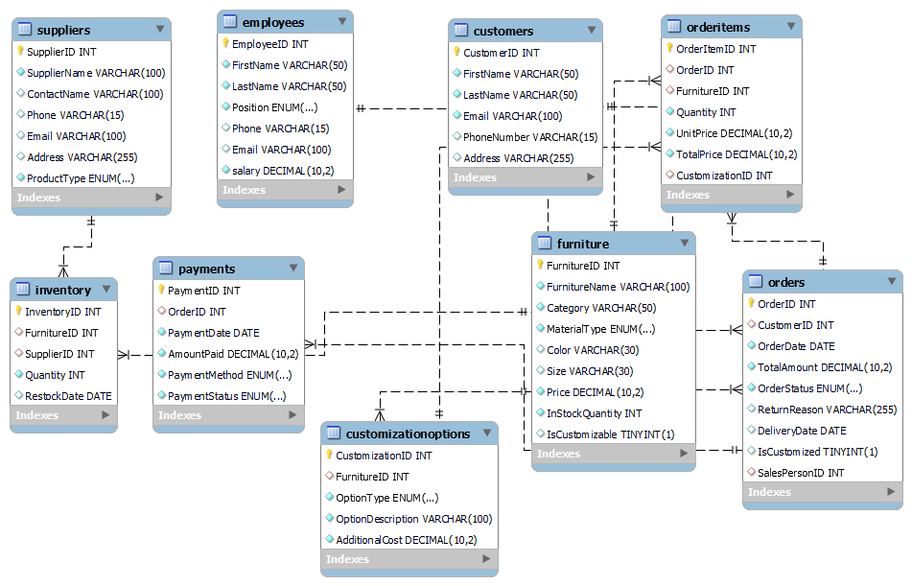**ER Diagram**

**Select & DESC**

select * from **Furniture**;

select * from **OrderItems**;

**DESC**

desc **customers**;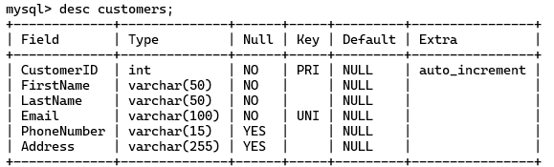

desc **CustomizationOptions**;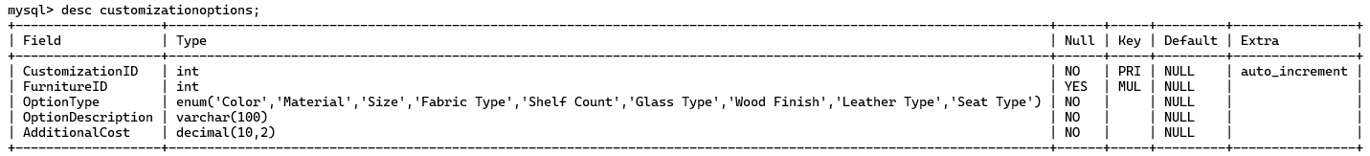

desc Suppliers;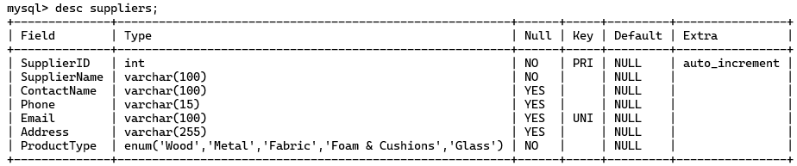

------------------------------------------------------------------------------------------------------------------ **QUESTIONS** -----

ALTER TABLE Orders

ADD SalesPersonID INT,

ADD FOREIGN KEY (SalesPersonID) REFERENCES Employees(EmployeeID);

UPDATE Orders SET SalesPersonID = 1 WHERE OrderID = 1; -- Ravi Kumar

UPDATE Orders SET SalesPersonID = 8 WHERE OrderID = 2; -- Priya Sharma

UPDATE Orders SET SalesPersonID = 9 WHERE OrderID = 3; -- Ravi Kumar

UPDATE Orders SET SalesPersonID = 1 WHERE OrderID = 4; -- Amit Mehta

UPDATE Orders SET SalesPersonID = 1 WHERE OrderID = 5; -- Priya Sharma

UPDATE Orders SET SalesPersonID = 8 WHERE OrderID = 6; -- Amit Mehta

UPDATE Orders SET SalesPersonID = 9 WHERE OrderID = 7; -- Ravi Kumar

UPDATE Orders SET SalesPersonID = 9 WHERE OrderID = 8; -- Priya Sharma

UPDATE Orders SET SalesPersonID = 9 WHERE OrderID = 9; -- Amit Mehta

UPDATE Orders SET SalesPersonID = 8 WHERE OrderID = 10; -- Ravi Kumar

UPDATE Orders SET SalesPersonID = 8 WHERE OrderID = 11; -- Priya Sharma

UPDATE Orders SET SalesPersonID = 9 WHERE OrderID = 12; -- Ravi Kumar

UPDATE Orders SET SalesPersonID = 8 WHERE OrderID = 13; -- Amit Mehta

UPDATE Orders SET SalesPersonID = 8 WHERE OrderID = 14; -- Priya Sharma

UPDATE Orders SET SalesPersonID = 9 WHERE OrderID = 15; -- Amit Mehta

UPDATE Orders SET SalesPersonID = 1 WHERE OrderID = 16; -- Ravi Kumar

UPDATE Orders SET SalesPersonID = 1 WHERE OrderID = 17; -- Priya Sharma

UPDATE Orders SET SalesPersonID = 1 WHERE OrderID = 18; -- Amit Mehta

UPDATE Payments

SET PaymentStatus = 'Pending'

WHERE PaymentID = 4;

UPDATE Payments

SET PaymentStatus = 'Pending'

WHERE PaymentID = 10;

UPDATE Payments

SET PaymentStatus = 'Pending'

WHERE PaymentID = 7;

UPDATE Payments

SET PaymentStatus = 'Half_Paid'

WHERE PaymentID = 11;

-- Retrieve all orders placed by a customer with CustomerID = 1.

SELECT * FROM Orders

WHERE CustomerID = 1;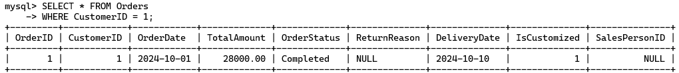

-- Find all furniture items where InStockQuantity is 12

SELECT FurnitureName, Category, Price FROM Furniture

-- List all furniture items that are customizable.

SELECT FurnitureName, Category, MaterialType FROM Furniture

-- Calculate the total revenue for orders marked as Completed.

SELECT SUM(TotalAmount) AS TotalRevenue FROM Orders

-- List furniture categories and their total quantities sold, ordered by popularity.

SELECT F.Category, SUM(OI.Quantity) AS TotalQuantitySold

FROM OrderItems OI

JOIN Furniture F ON OI.FurnitureID = F.FurnitureID

GROUP BY F.Category

-- Retrieve all suppliers who provide wood materials.

SELECT * FROM Suppliers

-- List all pending payments with order information.

SELECT P.PaymentID, P.OrderID, P.AmountPaid, P.PaymentMethod, O.TotalAmount

FROM Payments P

JOIN Orders O ON P.OrderID = O.OrderID

-- Find names of customers who have placed at least one customized order.

SELECT DISTINCT C.FirstName, C.LastName

FROM Customers C

JOIN Orders O ON C.CustomerID = O.CustomerID

-- Find the average salary for each position in the Employees table.

SELECT Position, AVG(salary) AS AvgSalary

FROM Employees

GROUP BY Position;

-- List all furniture items supplied by SupplierID = 2.

SELECT F.FurnitureName, F.Category, F.MaterialType, I.Quantity

FROM Inventory I

JOIN Furniture F ON I.FurnitureID = F.FurnitureID

WHERE I.SupplierID = 2;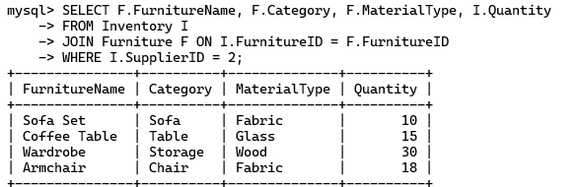

-- Retrieve all returned orders with their reasons.

SELECT OrderID, ReturnReason

FROM Orders

-- List furniture items priced above 25000.

SELECT FurnitureName, Price, Category

FROM Furniture

-- Count the total number of orders per customer.

SELECT C.CustomerID, C.FirstName, C.LastName, COUNT(O.OrderID) AS TotalOrders

FROM Customers C

LEFT JOIN Orders O ON C.CustomerID = O.CustomerID

GROUP BY C.CustomerID, C.FirstName, C.

-- List all employees whose position is Salesperson with salary.

SELECT FirstName, LastName, Email,salary

FROM Employees

-- Retrieve customization options for a furniture item with FurnitureID = 6.

SELECT OptionType, OptionDescription, AdditionalCost

FROM CustomizationOptions

-- Find all customers whose name start with 'a' letter

SELECT FirstName, LastName, Email

FROM Customers

-- Find all furniture items that contain the word "Table" in their name.

SELECT FurnitureName, Category, Price

FROM Furniture

-- Retrieve all suppliers whose phone numbers start with "91" (Indian country code).

SELECT SupplierName, Phone

FROM Suppliers

-- List all furniture items that come in colors starting with "B" (e.g., "Blue", "Black")

SELECT FurnitureName, Color

FROM Furniture

-- Retrieve all orders with statuses starting with "C" (e.g., "Completed", "Cancelled").

SELECT OrderID, OrderStatus, TotalAmount

FROM Orders

-- Get the total quantity of each furniture category in stock.

SELECT Category, SUM(InStockQuantity) AS TotalQuantityInStock

FROM Furniture

-- List all categories with total sales above rs 15,000.

SELECT F.Category, SUM(OI.TotalPrice) AS TotalSales

FROM OrderItems OI

JOIN Furniture F ON OI.FurnitureID = F.FurnitureID

GROUP BY F.Category

-- how many furniture purchase on 2024-10-10

SELECT SUM(oi.Quantity) AS TotalFurniturePurchased

FROM Orders o

JOIN OrderItems oi ON o.OrderID = oi.OrderID

-- which customer purchased which furniture

SELECT CONCAT(c.FirstName, ' ', c.LastName) AS CustomerName,

f.FurnitureName AS PurchasedFurniture, oi.Quantity AS QuantityPurchased,

o.OrderDate AS PurchaseDate, o.TotalAmount AS TotalOrderAmount

FROM Customers c

JOIN Orders o ON c.CustomerID = o.CustomerID

JOIN OrderItems oi ON o.OrderID = oi.OrderID

JOIN Furniture f ON oi.FurnitureID = f.FurnitureID

ORDER BY o.

**Conclusion**: -

The furniture shop database is designed to efficiently manage customer relationships, order processing, inventory, and supplier interactions. It enhances customer satisfaction by organizing customer data and streamlining order fulfillment through interconnected tables like **Customers**, **Orders**, **OrderItems**, **Furniture**, and **Payments**. The database supports effective inventory control and financial management, ensuring optimal stock levels and accurate transaction tracking. Additionally, it facilitates employee management, allowing for improved customer service. Overall, the database provides a scalable and secure solution that contributes to the shop's operational efficiency and profitability while accommodating future growth and evolving business needs.

***********************

**\*\*\* THE END \*\*\***

***********************